Laboratory works №9
Dimension reduction with SVD

Tasks
For the corresponding dataset, according to the option, reduce the dimensionality of the data using PCA and SVD. Datasets are placed in the datasets folder (https://github.com/a-vodka/dv/tree/master/lab/dataset).
- Using PCA to visualize data in two- and three-dimensional (2D and 3D) spaces. Use PCA class for sklearn.
- Calculate SVD of your dataset, plot the dependence of the eigenvalues of the matrix on their number. Before plotting, arrange the eigenvalues in descending order.
- Determine the smallest value of the space size i for which relation (3) is satisfied. Where λi are the eigenvalues of the matrix, n is the total number of eigenvalues, 0.8 – is level of data significance.
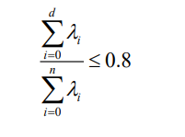
- Set λi to zero for which d ≤ i ≤ n. Perform the reverse transformation and compare the obtained data with the original.
- Set d = 2 (for 2D) and d = 3 (3D) and perform and plot first d columns of reconstructed data. Compare graph with obtained on step 1.

PCA was applied to visualize the data in 2D and 3D spaces using the sklearn.decomposition.PCA class, with points colored by the 'Channel' feature. The scatter plots, "PCA 2D Visualization" and "PCA 3D Visualization," highlight the data's structure across the first two and three principal components (Figure 1).
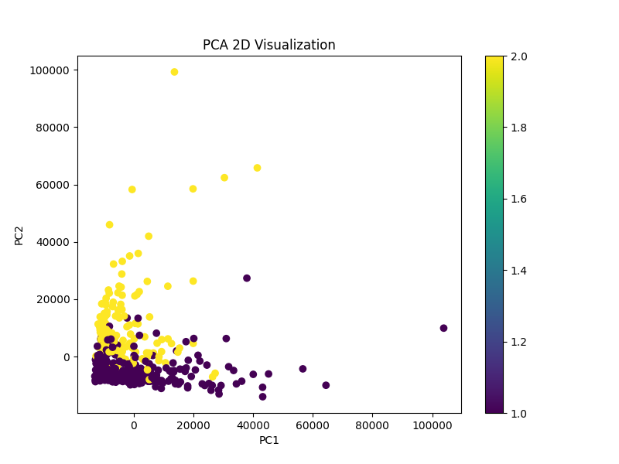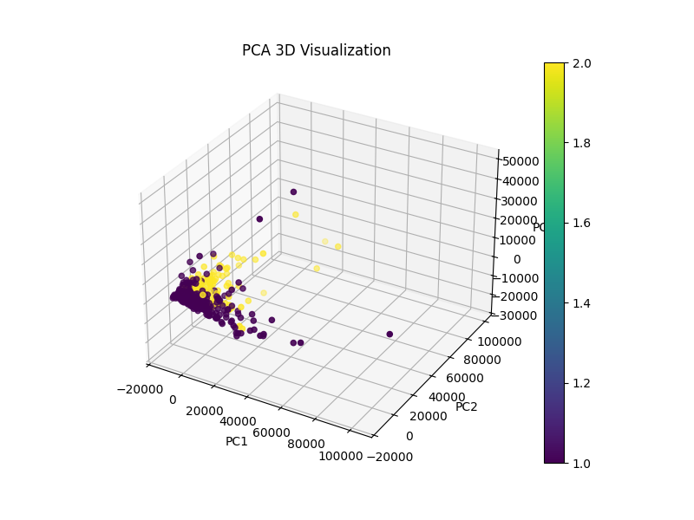
Figure 1 – PCA 2D and PCA 3D Visualization

SVD was used to decompose the dataset, and eigenvalues (λi = σi² / (m-1)) were plotted in descending order. The "Eigenvalues in Descending Order" graph shows a rapid decline, indicating most variance is captured by initial components (Figure 2)
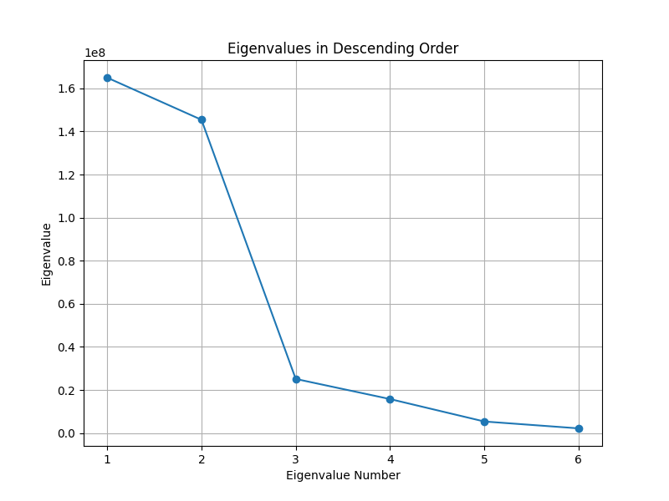
Figure 2 - Eigenvalues in Descending Order
The smallest dimension (d) retaining 80% variance was determined as d = 2, with an explained variance of 0.8648, exceeding the threshold (Figure 5).
Dimensionality was reduced by setting singular values to zero for i ≥ d (from the third component onward when d = 2). The reverse transformation yielded an MSE of 8071660.7439 compared to the original data, with a smoothed trend observed in the "Comparison of First Feature: Original vs Approximated" plot (Figure 3).
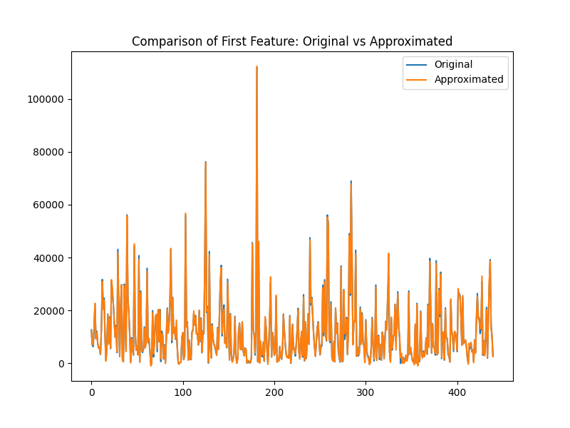
Figure 3 – Comparison of First Feature: Original vs Approximated

For d = 2 and d = 3, the first d columns of reconstructed data were plotted as "Reconstructed 2D Visualization (First 2 Columns)" and "Reconstructed 3D Visualization (First 3 Columns)" (Figure 4). The reconstructed plots retain the general clustering observed in the PCA visualizations but reflect the reduced dimensionality effect.
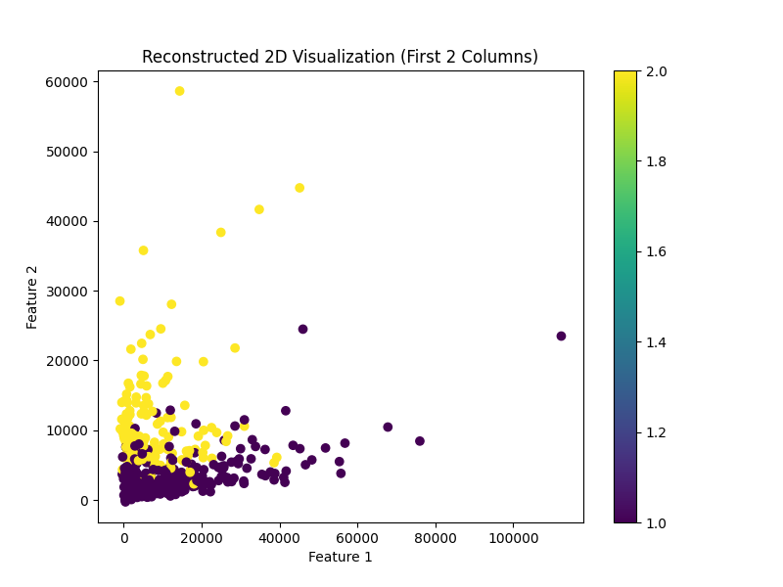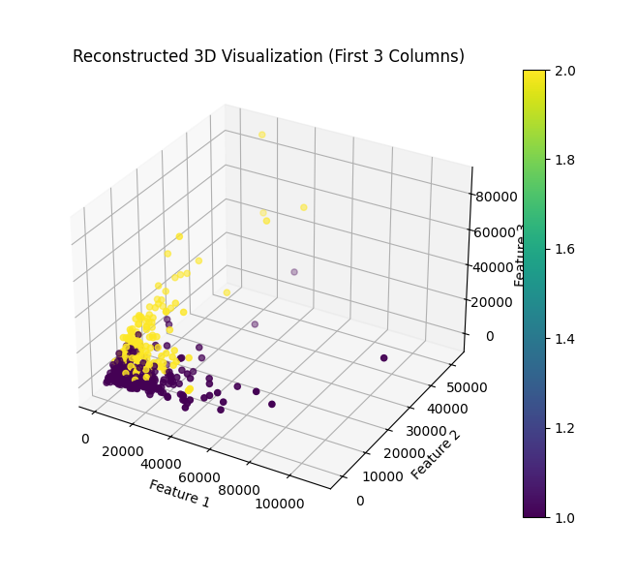
Figure 4 – Reconstructed 2D (First 2 Columns) and 3D Visualization (First 3 Columns)

The analysis successfully fulfills the task, confirming that two dimensions capture over 86% of variance effectively.
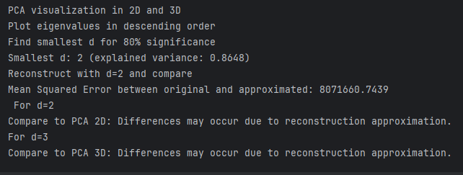
Figure 5 – Summary of PCA and SVD Dimensionality Reduction Analysis

